Logic & AI

Ashraf Adel 196280

Farah Aymen 194233

Jacinta Samir 206562

Handwritten Equations to LaTeX Conversion

Reading handwritten equations and converting them to latex

Table of Contents

**1.** **Project Summary** 3

PAGE 3

PEAS 3

**2.** **Problem description** 4

**3.** **Data Set Used** 5

**4.** **Proposed Approach** 6

4.1 Preparing The dataset For Training: 9

4.2 Training The Model 10

4.3 Developing The GUI 11

“App” Class 11

“SnipWidget” Class 16

**5.** **Experiments** 19

5.1 First Attempt 19

5.2 Second Attempt 20

5.3 Third Attempt 21

5.4 Fourth Attempt 22

5.5 Fifth Attempt 23

5.6 Sixth Attempt 24

**6.** **Results** 25

**7.** **Tools Used** 28

**8.** **How to Use** 28

# **Project Summary**

This project takes an image of a handwritten equation, segments it into symbols, evaluates these symbols on a neural network, then it gets its LaTeX and displays it to the user on the GUI. The user in general snips the equation he wrote and gives it to the system, then the system displays the latex for him. It first takes the image and segments it by first detecting each connected region together and crops according to it. It takes the approach from top to bottom and from right to left in detecting where the symbols at so it segments them in order. Then, using an artificial neural network, the network takes those symbols one by one and evaluates it with the trained model. Next, the model converts the detected symbol to what refers to the LaTeX of it.

## PAGE

|  |  |  |  |
| --- | --- | --- | --- |
| **Preceptors** | **Actions** | **Goals** | **Environment** |
| * Snipped image of the equation | * Predict the handwritten equation * Display the LaTeX equivalent | * Minimize the incorrect translated symbols | * The GUI the user uses * The equation image. |

## PEAS

|  |  |  |  |
| --- | --- | --- | --- |
| **Performance Measure** | **Environment** | **Actuators** | **Sensors** |
| * Measure the accuracy of the trained neural network model using evaluation metrics (accuracy metric) | * Predict the handwritten equation. * Display the LaTeX equivalent. | * Minimize the incorrect translated symbols | * The GUI the user uses * The equation image. |

* The arguments in the compile function of the NN model is considered the evaluation function

# **Problem description**

It has been a problem for many users to find a picture of an equation online but can’t take the text itself or writing an equation on paper but can’t just plop it as a text. Writing equations symbol by symbol can be difficult, exhausting and time consuming. This project aims to make the process easier by just inserting an image of the equation and getting its LaTeX. This is considered as a real-life problem where this project will ease the users from this burden. It will help researchers, students, etc. to easily insert whatever equation regardless on how complex it is and it will be automatically translated to them immediately.

# **Data Set Used**

The dataset used in this project is found on Kaggle it is called *Handwritten Math Symbols Dataset*



It offers around 79 different classes and over 100,000 image samples. Since the dataset was huge and had a drawback that it was imbalanced, we used only part of it. We used the necessary symbols of total 32 classes. The dataset is loaded in pickle files for further use.

# **Proposed Approach**

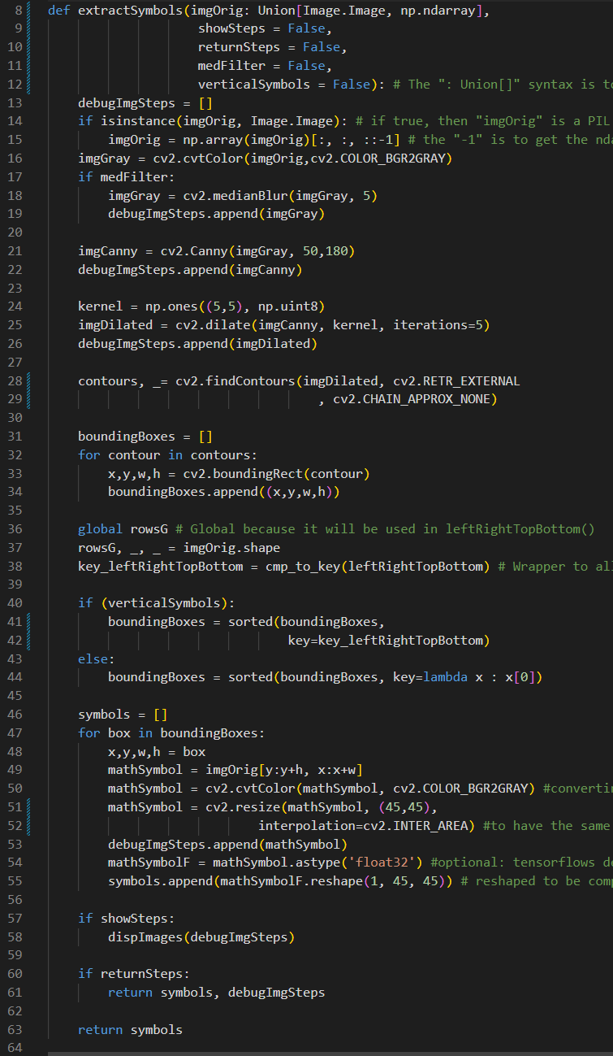The approach of this project is to first read the image and perform some pre-processing on it so it can segment it properly.  
First through the following function, it converts the image to grayscale and performs a median blur on it if “med Filter” is True. Second, it detects the edges on the filtered image with canny. Third, it dilates the image and find the contours of it. Fourth, it puts bounding boxes on the symbols with a defined function called leftRightTopBottom that makes it scan the image from left to right and top to bottom so it can read the image sequentially.

Regarding the leftRightTopBottom() function, it gives priority to the y-coordinate of the math symbol in the image; if the symbol is at the top, then it is read first, then the symbol at the middle, and so forth. Note that this function is the key function used in sorting only if “verticalSymbols” parameter is “True” in extractSymbols()

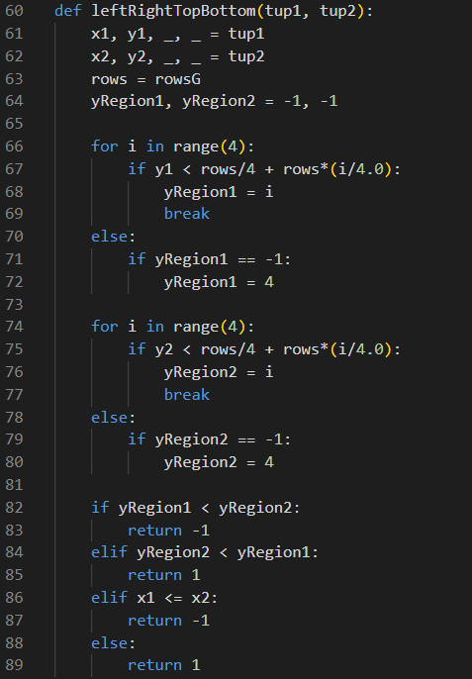

the dispImages() is used to display the image processing steps that extractSymbols() have done to crop the symbols from the input images, and this function will only run if the parameter “showSteps” is “True”

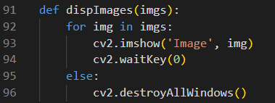

Then, we created a dictionary to hold the LaTeX equivalent for each class so after the model detects it, it matches with it.

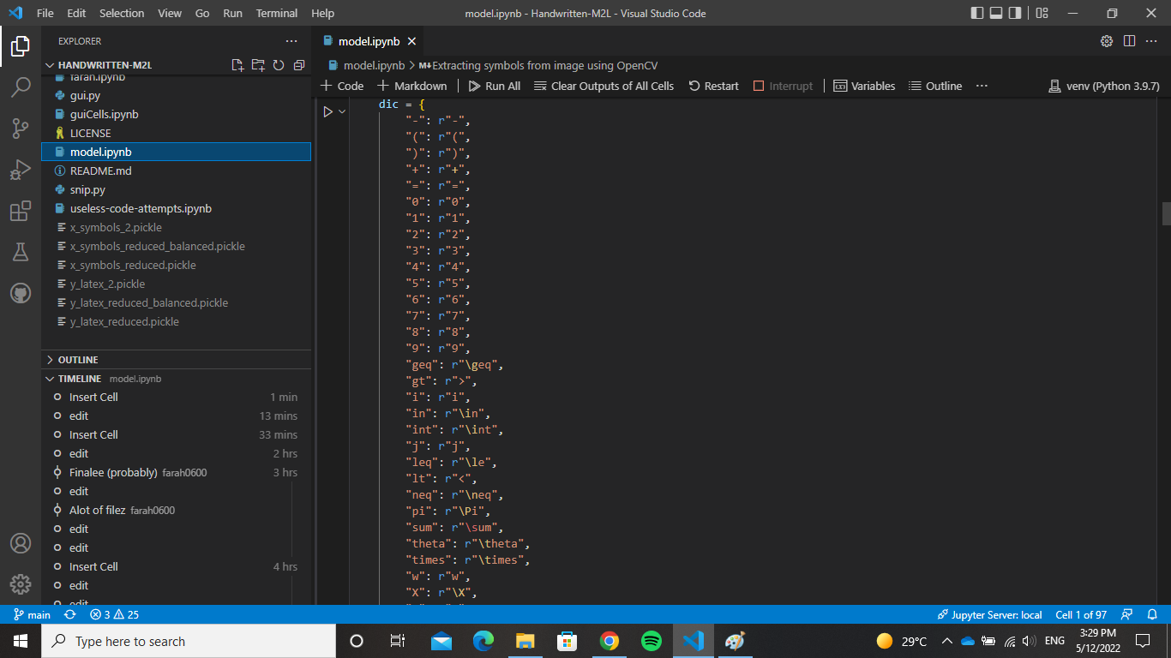

First, we loaded the dataset into a pickle file so it would be easiest to dump and load from through a function:

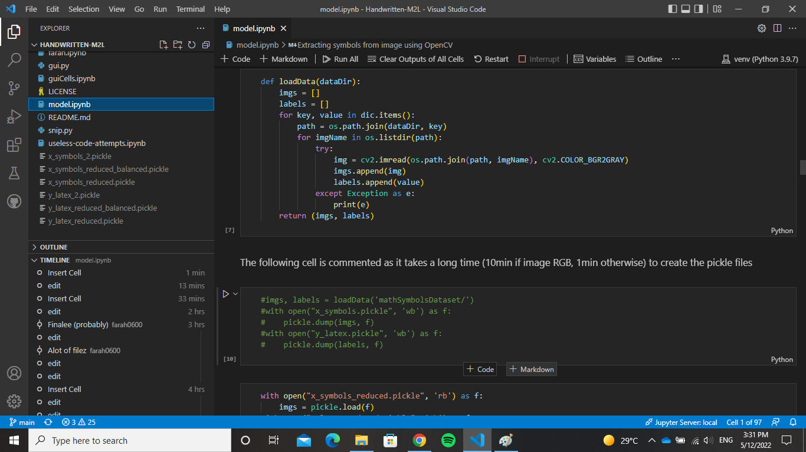

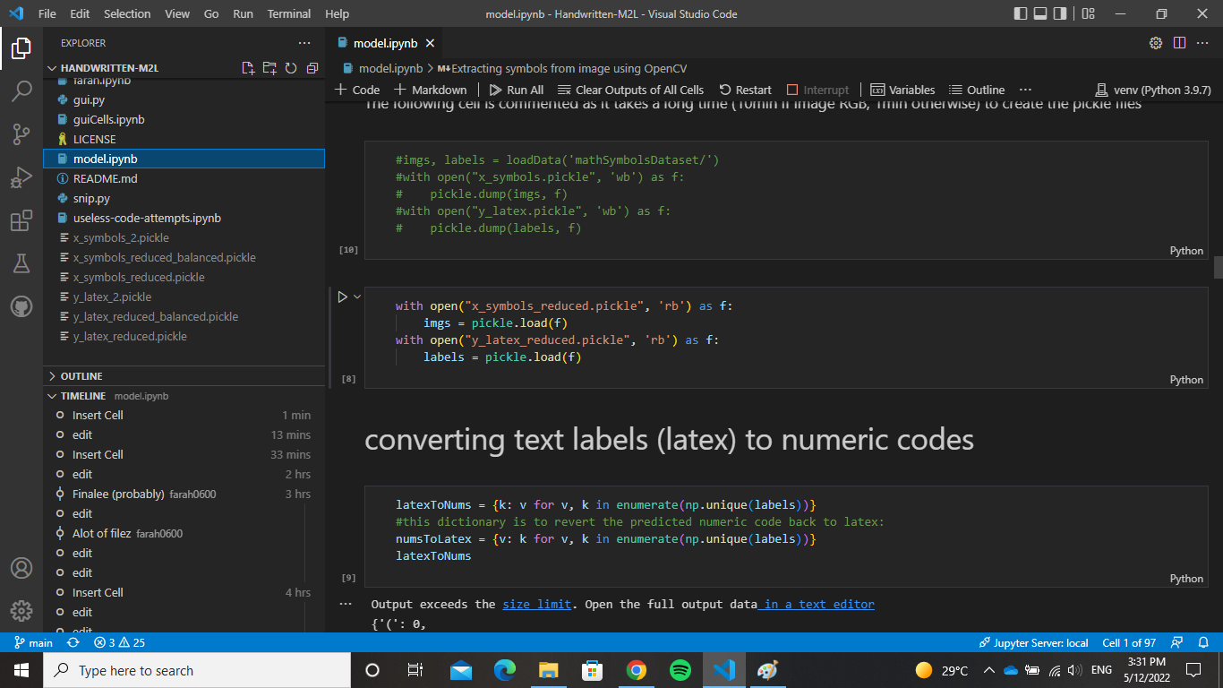



Next, we created another dictionary to revert the numeric code that the model predicted to its original class.

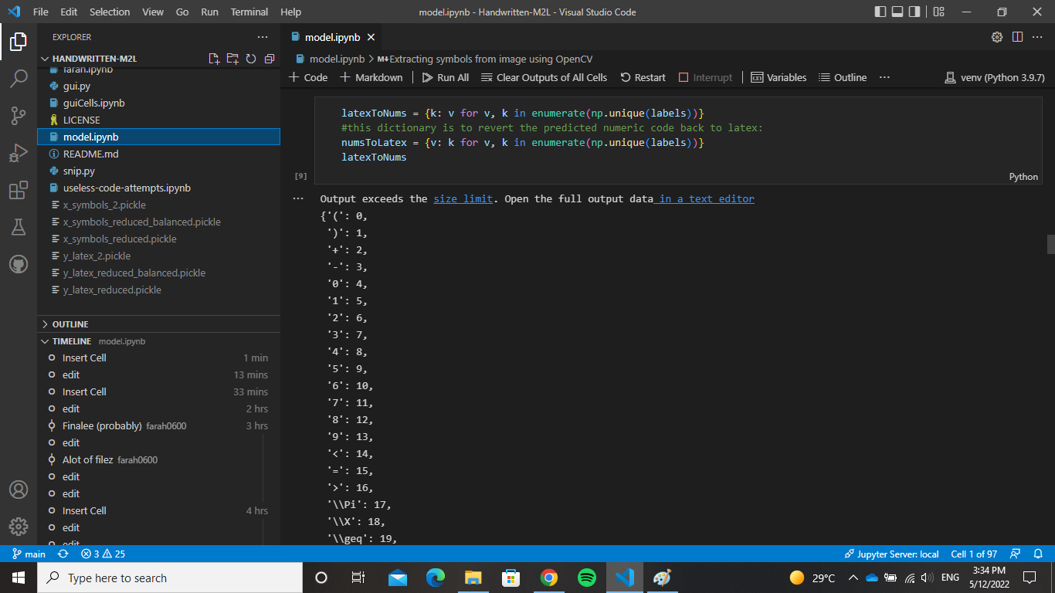

## 4.1 Preparing The dataset For Training:

We split the data set from trainging and testing then normalize the images so it would be more efficient during training.

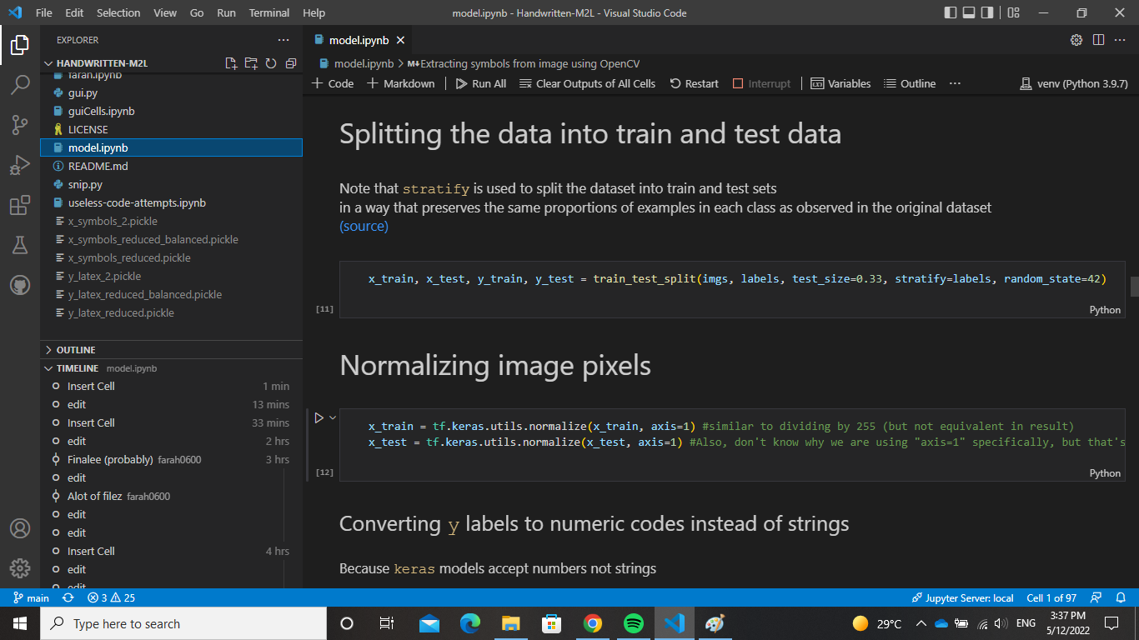

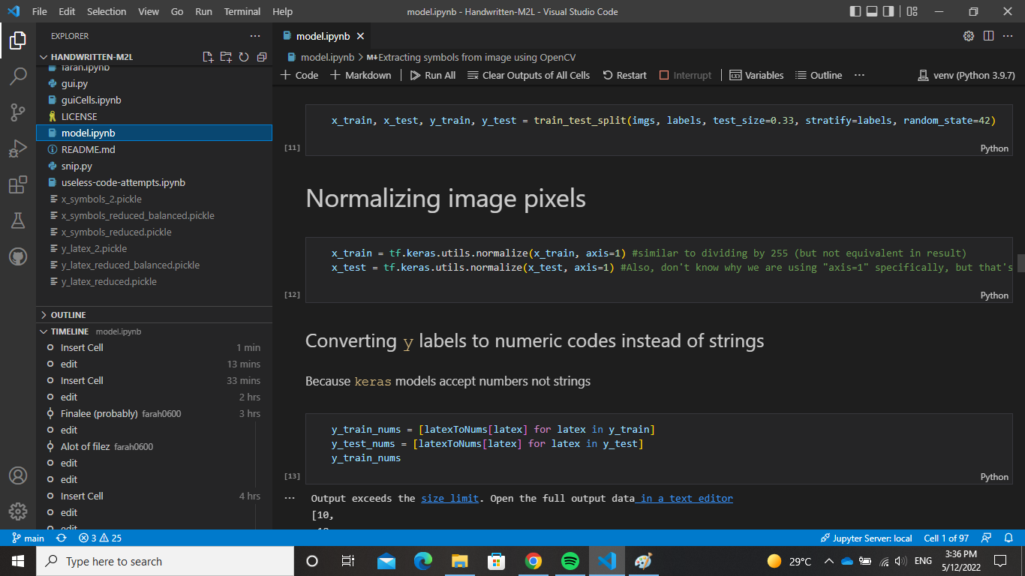

## 4.2 Training The Model

The neural network is composed of 3 layers, the first 2 hidden layers consist of 2025 neuron while the output layer contains 32 output neurons as they are 32 classes. The choice of 2025 is that it’s the same number of the pixels as suggested by some experts. The hidden layers are using Relu function as an activation function which is a function that fires when the value is postive otherwise, it assigns it to zero.

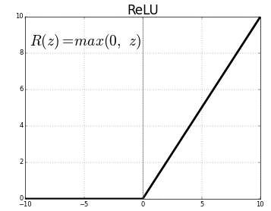

The output layer uses sofmax as an activation function which calculates the probability for each weight and chooses the highest one.

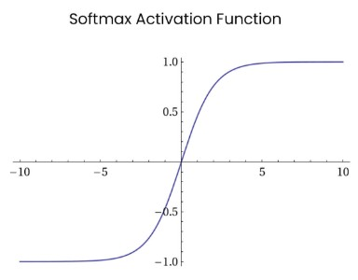

The optimizer used is adam optimizer which is considered an algorithm that accelerates the gradient decent algorithm by taking the average of the two gradient decents used. The loss is determined by the sparse categorical crossentropy which computes the loss bamong the classes and the labels.

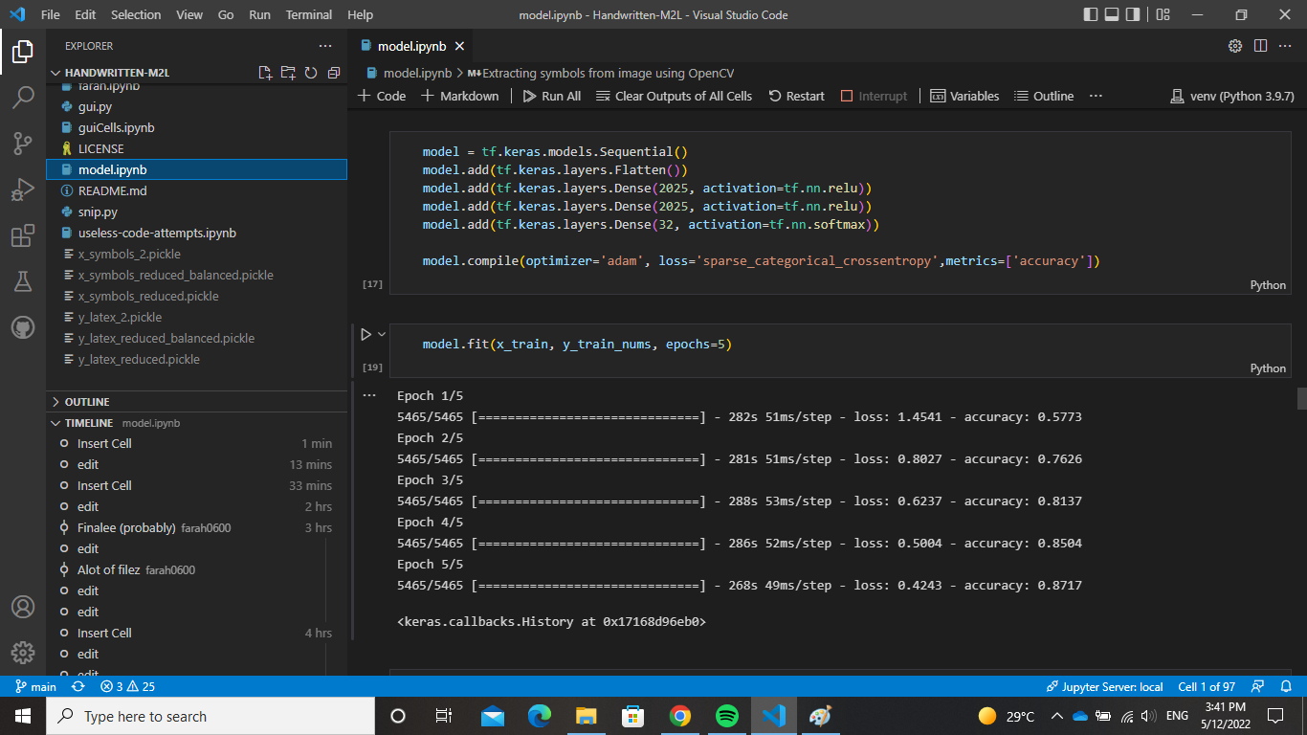



The model is trained with 87% of accuracy which is doable for the purpose of this model.

## 4.3 Developing The GUI

∵ The code of the GUI is a lot more than the rest of the files, comments have been written in the gui.py file that will facilitate understanding the details of the “App” class and the “snipWidget” class.

∴ Only a visualization of the main logic points of “gui.py” will be described:

### “App” Class

the  represents the class’s attributes while the  represents the class’s methods:

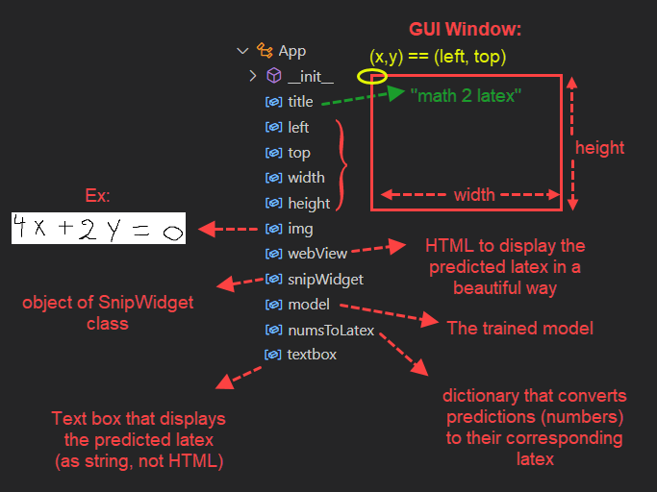

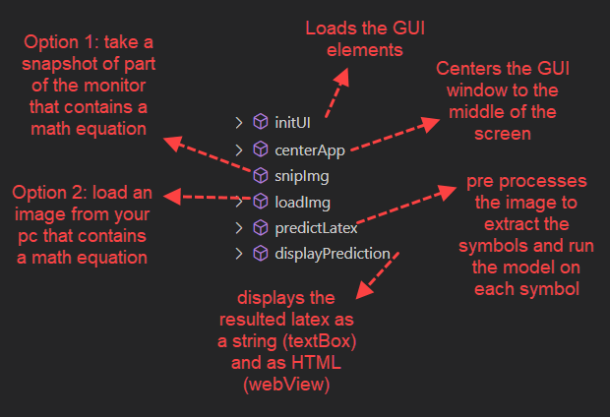

“App” object (the GUI) and the info displayed on the monitor (directory folders on the pc, any other windows opened for snipping, etc) → Environment

snipImg() & loadImg() → Sensor (Perceptor) Functions

predictLatex() → Agent Function

displayPrediction() → Actuator Function

Code:

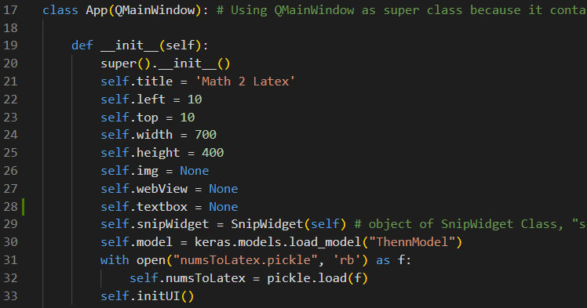

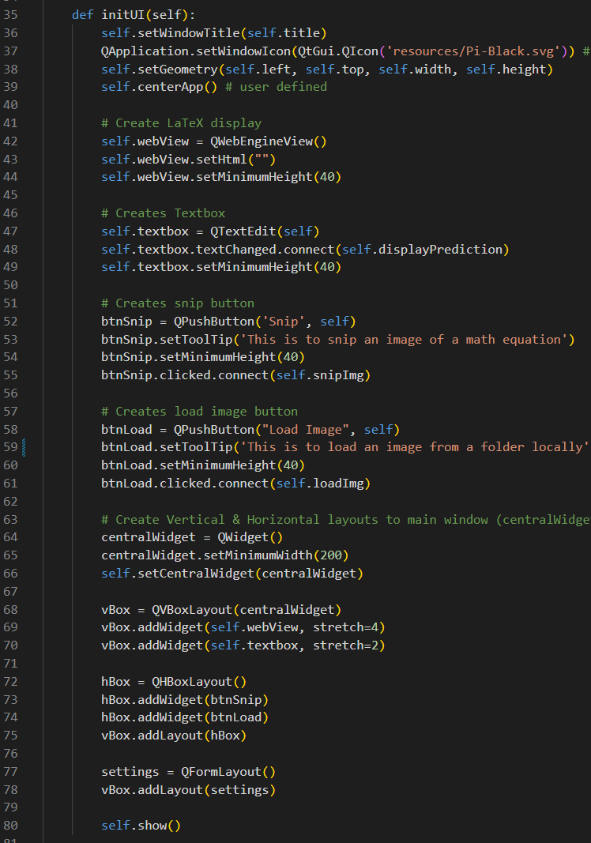

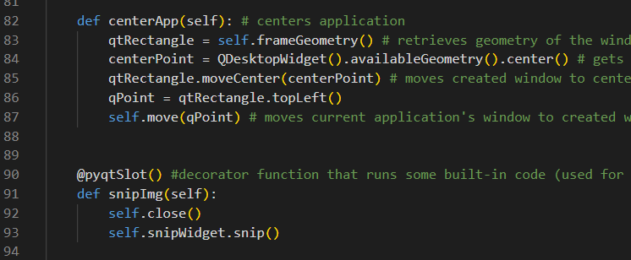

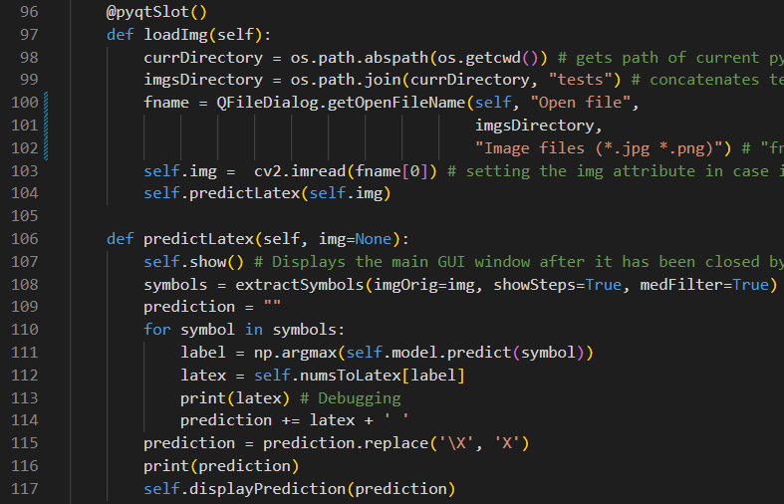

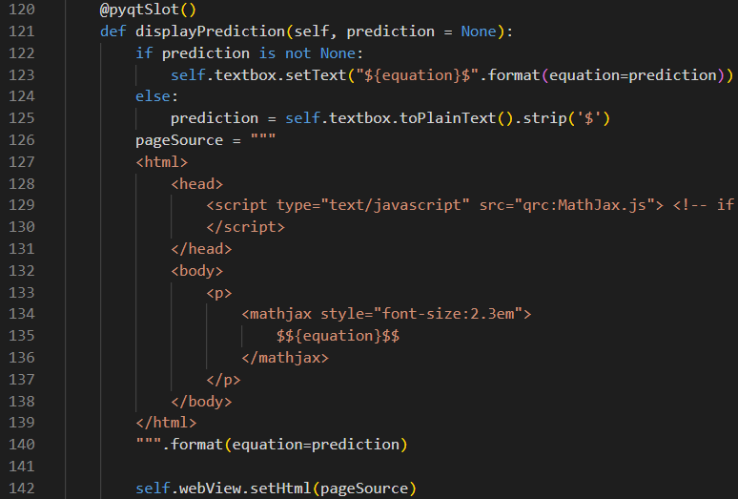

### “SnipWidget” Class

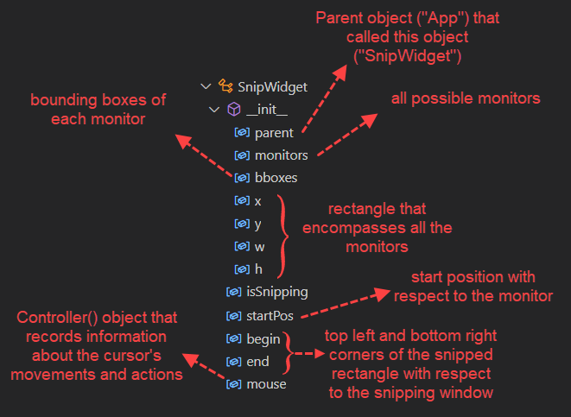

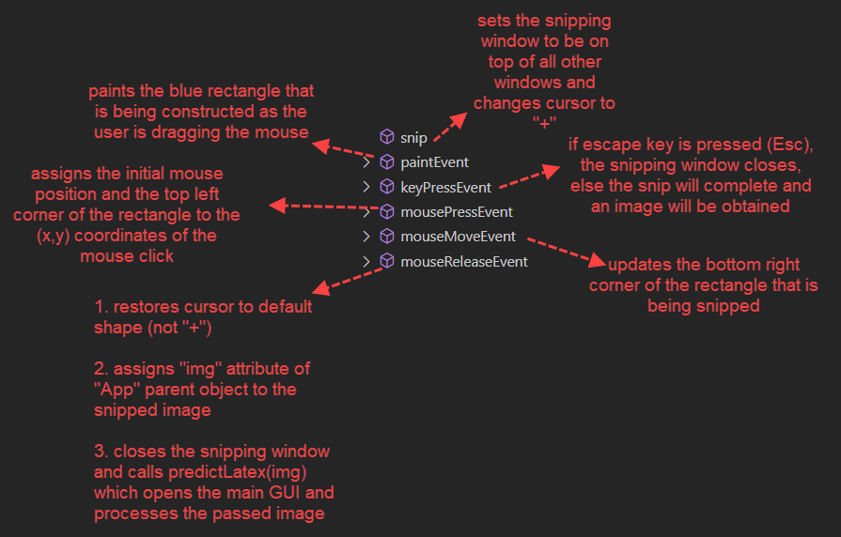

snip() → Sensor (Perceptor) Function

**Code:**

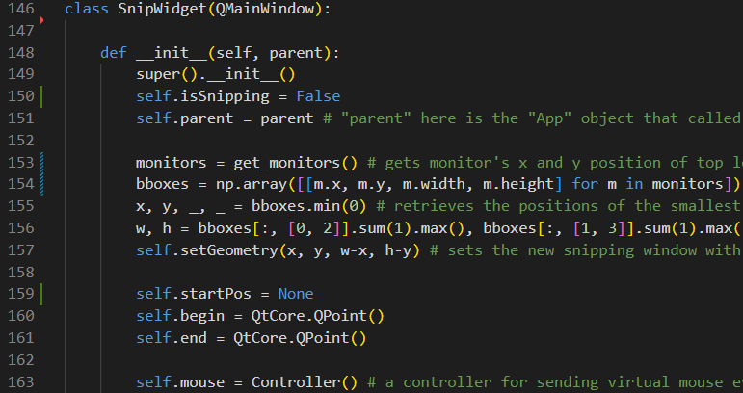

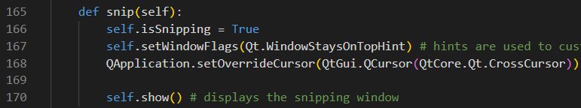

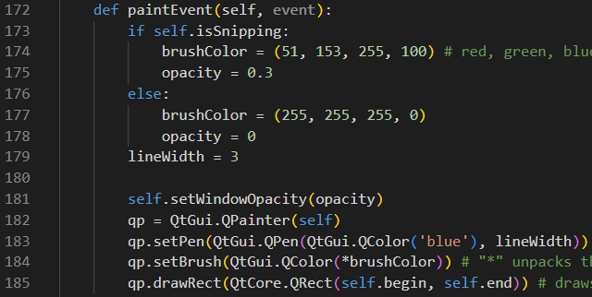

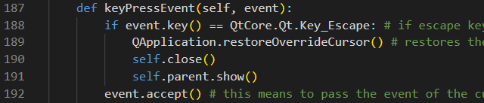

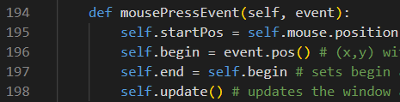

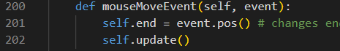

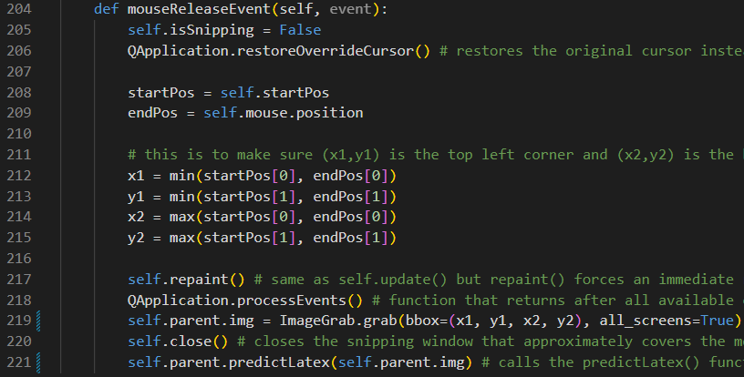

code that runs when typing “python gui.py” in the terminal:

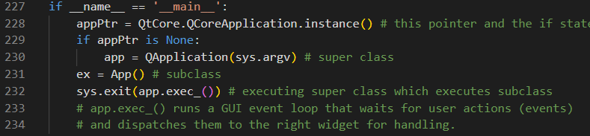

Basically, the code starts the “App” GUI.

# **Experiments**

This project has been experimented with six different attempts of 6 different neural network models without counting the working one to achieve the most accurate one.

## 5.1 First Attempt

In the first attempt a neural network was applied but with only 128 neurons for the two hidden layers and it turned out that they weren’t enough.

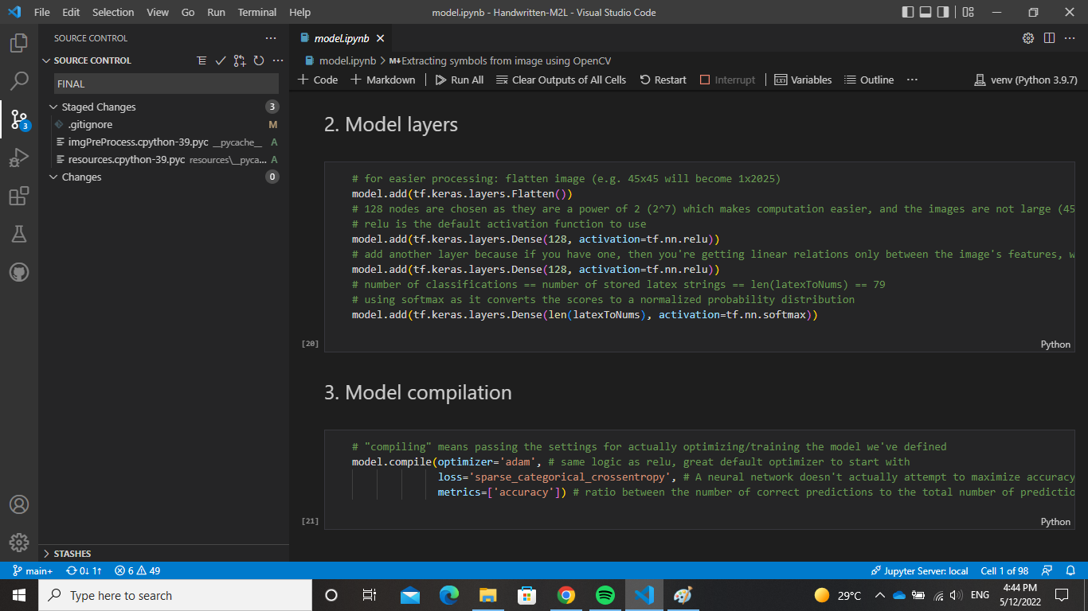



## 5.2 Second Attempt

The second attempt was to turn directions to the convolutional neural network since it is considered best practice for image data set, it creates filters and

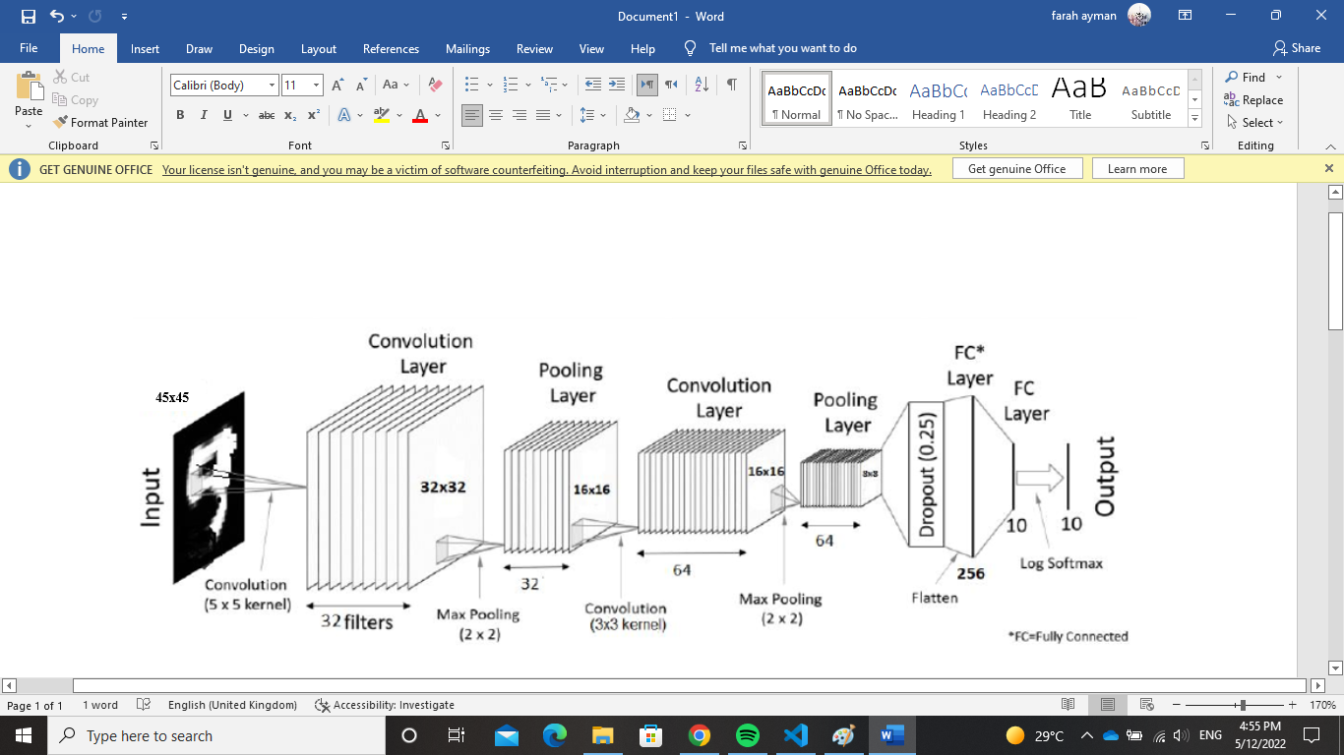

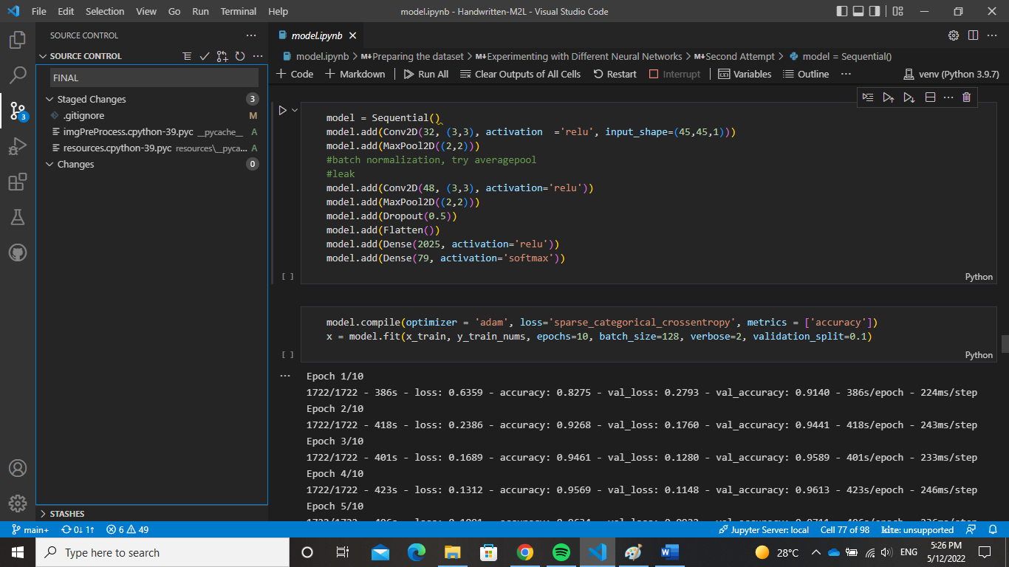

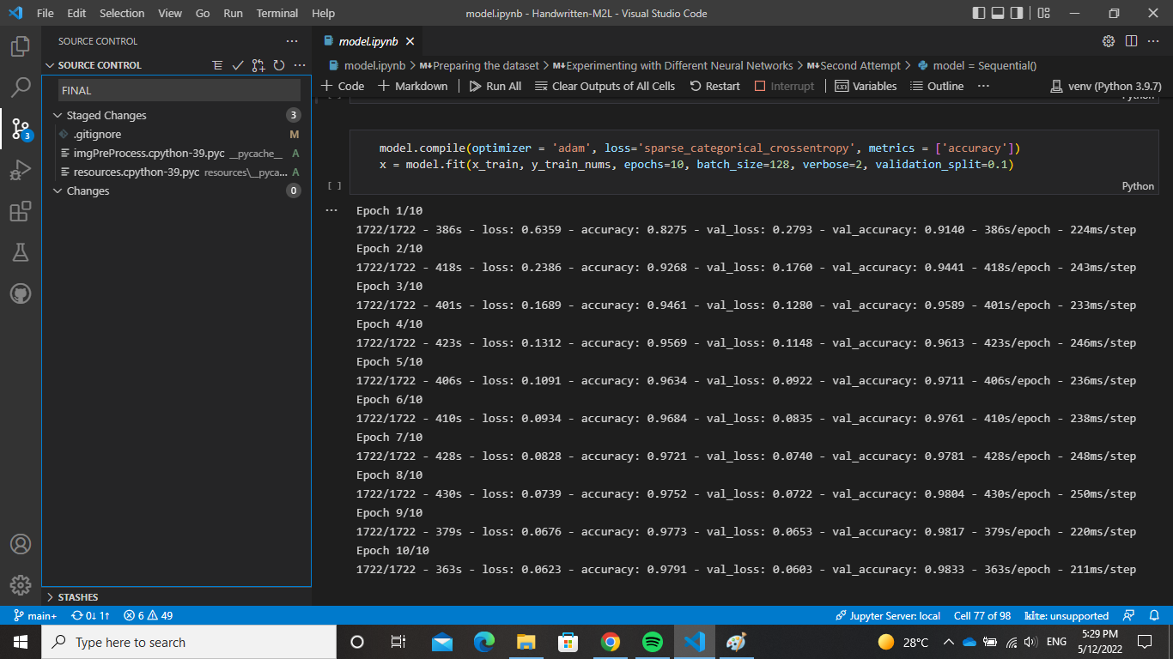

The images in the dataset are at size 45 x 45 pixels, first a convolutional layer of 32 filters is performed on the image with matrix 3x3 , then a max pooling of 32 layers with matrix 2x2. Then another convolutional layer of 64 filters is added with 3x3 matrix and a 64 Max Pooling layer is applied. Then lastly, a dropout of 0.5 to reduce overfitting.

The problem with this model is that it was too heavy and after all inaccurate. Although the model gave accuracy of 98%, it gave highly inaccurate results. We assumed this may have been caused due to overfitting.

## 5.3 Third Attempt

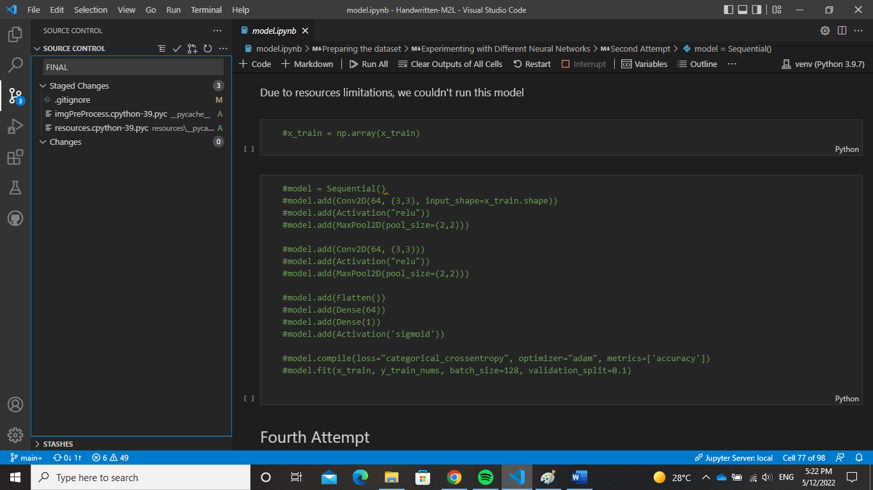

In this attempt, we tried to use sigmoid as the activation function but the model was too heavy to run, and it was discovered later that the sigmoid function is inappropriate for multi-categorical classes.

## 5.4 Fourth Attempt

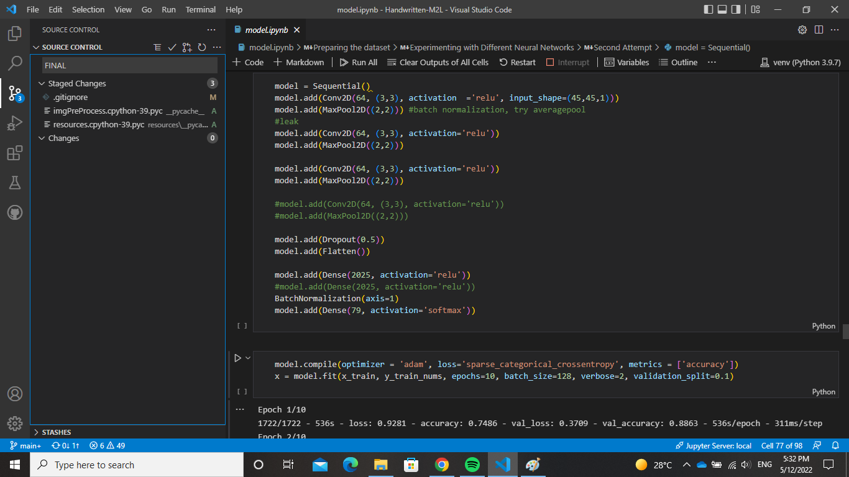

The fourth attempt was to try and add more layers to the model both convolutional and pooling layers. Nevertheless, the same problem was still present so it’s most probable that the overfitting was still existent Nevertheless, we concluded that extracting features from a character will not be appropriate since characters don’t have highlighting features to distinct between them and it can be fairly easy to confuse between their features. That’s why we decided to turn to the artificial neural networks yet again.

## 5.5 Fifth Attempt

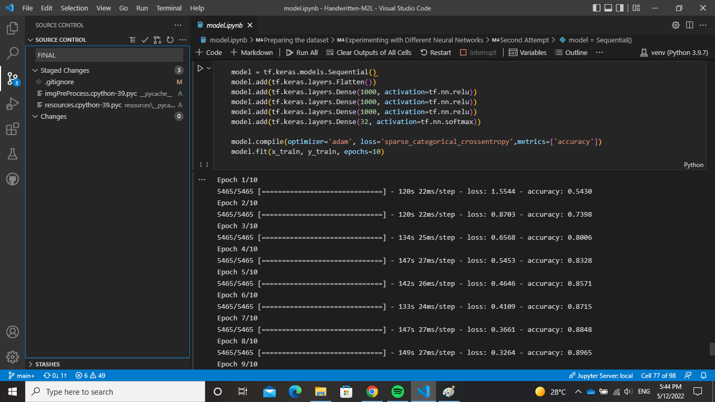

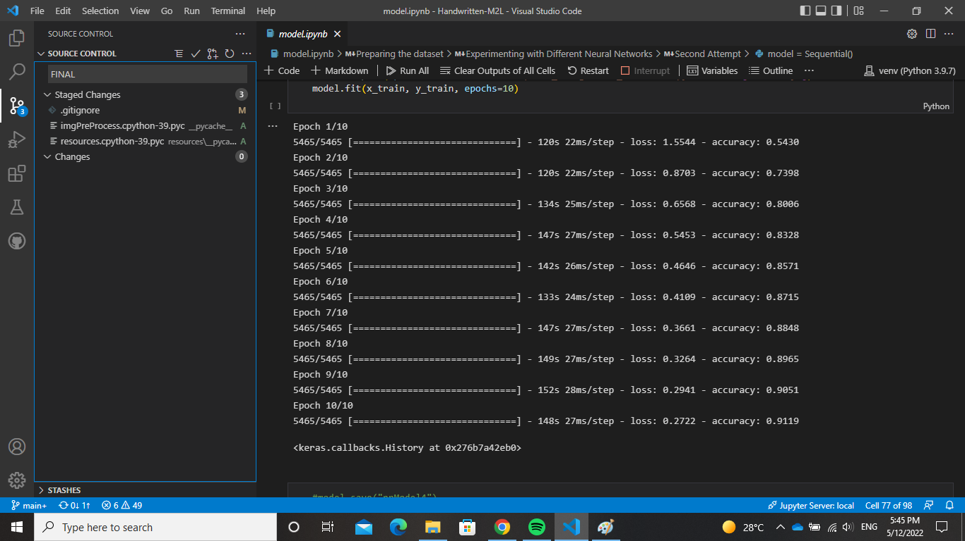

We decided to add another layer to the neural network to increase the accuracy but due to the heavy computations and the limited resources, adding 3 layers each has 2025 neurons and an output layer was not possible. So, we downsized it to 1000 neuron each but it was still inaccurate.

## 5.6 Sixth Attempt

In the final attempt, we discovered that the dataset is imbalance and that was what caused the inaccuracy although the accuracy of the models was 90+%. The issue was that many of the symbols were predicted as the one symbol that had too many samples in the dataset. So, we decided first to take an equal sample of all classes but some classes had way too few samples to take a sample out of it. Then, w decided to create class weights yet it did not work due to the variance in the sample size of each class.

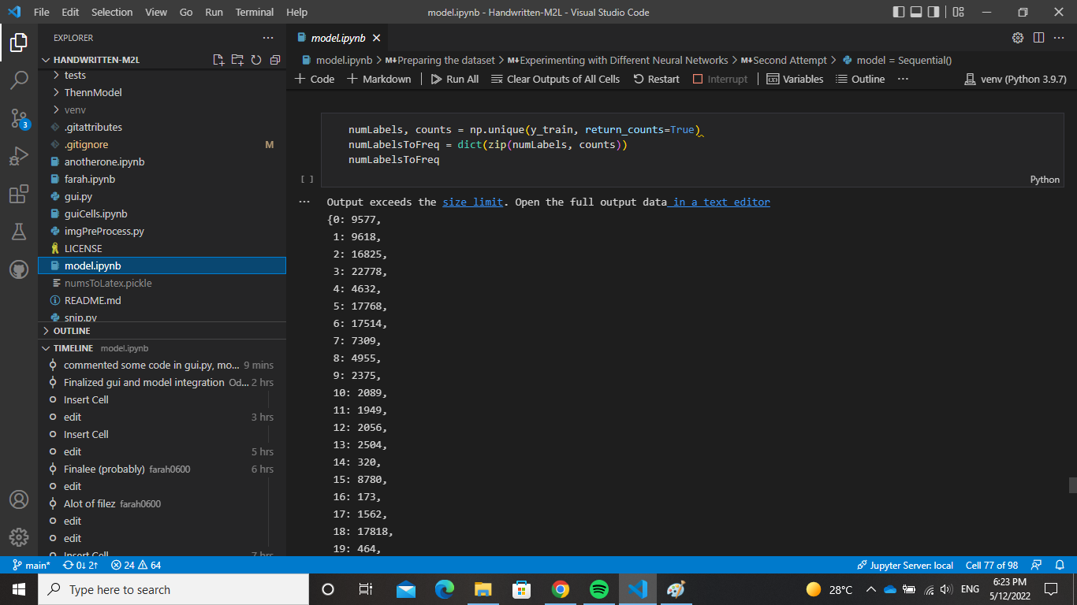

We tried to limit the lovely big class weights to 50 as there were overly big values.

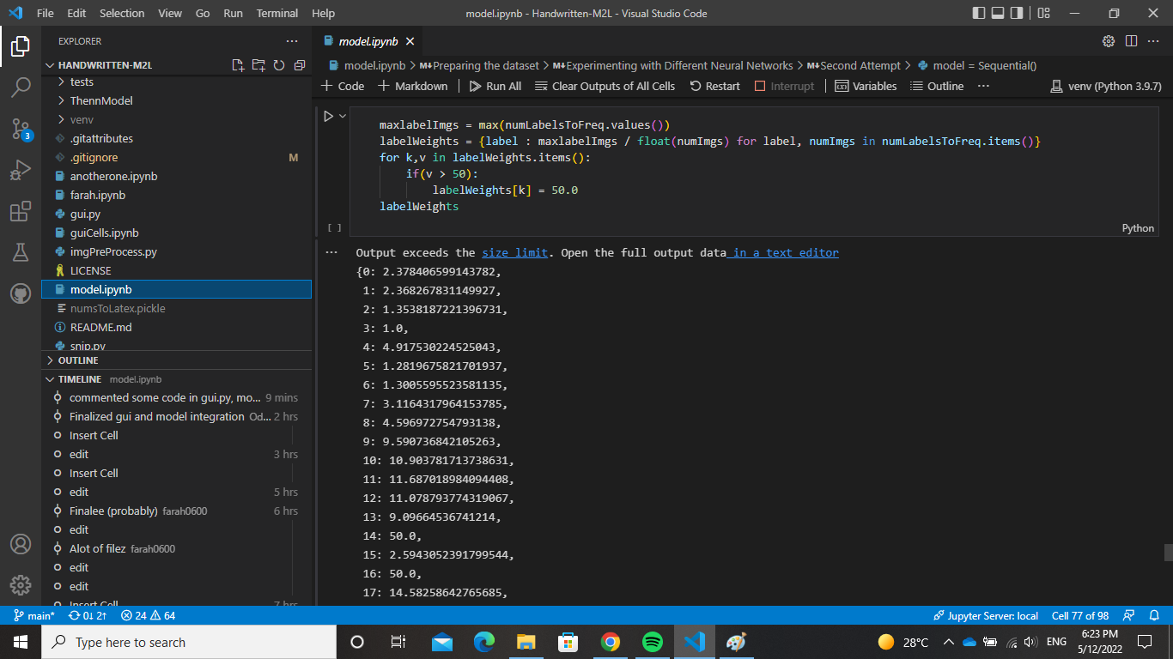

# **Results**

Note, these gifs are also named output1.gif, etc in the Handwritten-M2L folder.

Example on test1.png:



Example on test2.png:



Example on test3.png:



Example on test4.png and snip function (verticalSymbols=True):



# **Tools Used**

* The language used to implement this project was python, with the help of its many packages to do it.
* Tensor Flow, keras and skilearn for training NN models.
* PyQt5 for GUI
* open CV for displaying and processing images
* Jupyter Notebook
* HTML to display LaTex
* Javascript to elegantly display the LaTex
* VS Code IDE was used throughout the entire project

# **How to Use**

Finally, to use this application:

* + - 1. Pip install everything in the “requirements.txt” (done using pipreqs)  
         If some modules still could not be resolved, use “requirementsAll.txt”
      2. When unzipping the zip found in [this drive](https://drive.google.com/drive/folders/1G44LpOZjIL19jOgHQgBr_r77fdMOkS_0?usp=sharing) follow these steps:  
         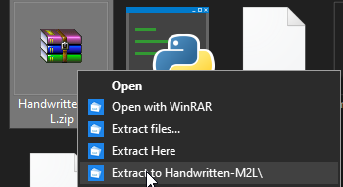  
         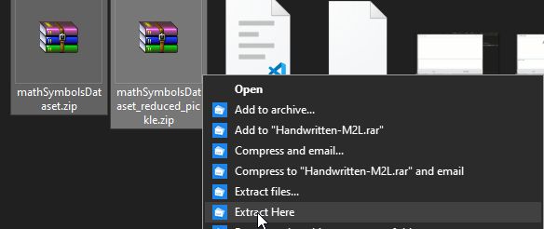
      3. “python gui.py” in terminal to run the GUI.